Victory Only Saddle Bag Liner Installation Instructions
****Do not open any of the bags labeled R or L until you read the entire instructions**** you’ll thank us later!!

Preparation, Tips and Techniques
Remove saddle bags; vacuum out and wash interior with a mild detergent like dish soap. Let dry. If you want to remove the lids you can, but it is not necessary.
We will be working one bag at a time to completion. The labeled bags in your kit are R and L, identified as if you are sitting on your bike. (Another identifier for Right hand side is the side is your throttle side).
Tape off (using masking tape) the rubber seal at the top of the bag. Be sure to tape off all the metal closures and rubber grommets inside the bag. The lid will take a little additional taping, we’ll walk you through that when get to it later.
Rule of thumb …if you don’t want glue on, tape it off.
The liner has some stretch, pieces are cut to fit. Only stretch if needed during installation.
DO NOT STRETCH OR PULL ON THEM PRIOR TO INSTALLATION! You should only need to employ the stretch to ensure the fit into corners and crevices.
Mineral spirits and a rag will keep your hands clean and help remove any excess glue that over sprays onto the carpet. Keep it near as you work the install.
Find a utensil in your kitchen drawer that has a plastic or wooden handle, you will be able to use this to smooth out the liner into the hard to reach spots.
The bags in your kit labeled R and L each have 7 pieces in them. Work with only one at a time…we will be starting with the Left (L).
The bag with the can of spray glue also has a scrap piece that may come in handy when you have completed the project. It is your FAILSAFE and will allow you to fill any areas that you were unable to pull together. Set this aside for now so you don’t mix it up with the liner pieces. We will go over any Failsafe methods at the end of the install. And yes, one can of glue is sufficient to do both saddle bags.
Lastly, you will be able to tell the face of the liner by the softer side. The side you will glue to the bag is coarser. Make sure you identify it in your trial fit…There is only one way for the piece to fit correctly but make sure you put glue on the correct side.

Let’s get started
Open the kit bag that is labeled L for Left there will be 7 pieces in this bag. Your left bag will be the clutch side of the bike.
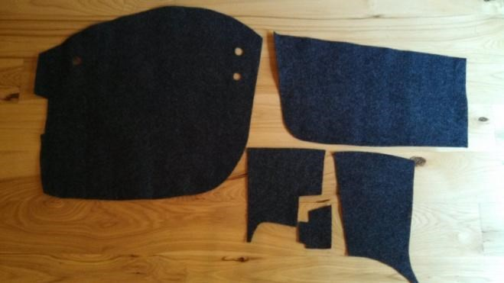

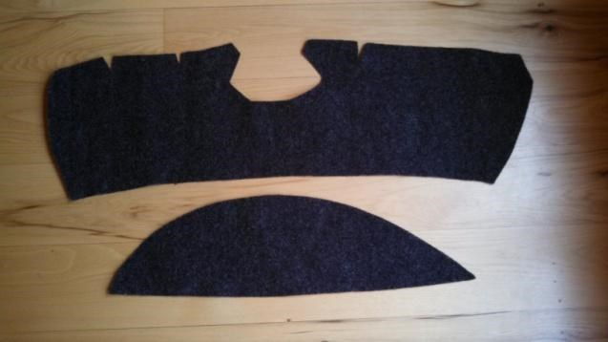
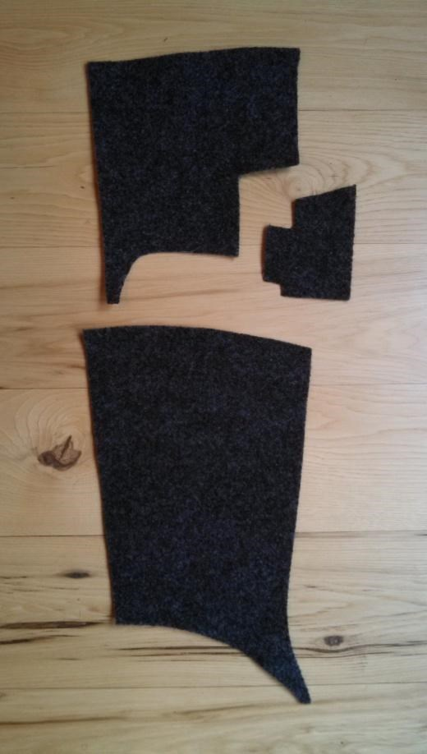
Photo A

- You will see a small box inside the saddlebag. Start with smallest piece shown in Photo A, this piece will cover the box. Trial fit the piece by aligning the long side of the piece at the side corner of the bag. Wrap the piece around the box and fold the flap down onto the top of the box. When you are comfortable with how it fits, lightly spray the back of the piece
and spray the box. Put the piece in place like it was for your trial fit, press and smooth in place and fold the flap down press the seams together.

- Stay on the side by the box using the piece shown at the very top of the Photo A. Again, trial fit the piece. Spray back of piece and inside of bag where the piece will go, don’t worry about running out of glue, spray liberally. Apply this piece by starting at the top, fit around the box you just covered and smooth out. If you have glue that was over sprayed on the box carpet, just take mineral spirits on a cloth and rub the glue spot until gone.
- Move to the opposite side of bag. Piece shown at bottom of Photo A. Trial fit, spray back of liner piece and then the inside of the bag. Start at the top and work down and along the sides. Smooth out all across and down the piece, stretch only if necessary.
- The next piece you install is the largest piece with the holes cut to fit around grommets, Photo B. Be patient with this piece.
It fits the back side of the bag and wraps down around the bottom. The trial fit on this is very important because of the size of the piece. Trial fit by placing the slit over the bar latch and get a feel for how it fits over the grommets, in and over the ridges, and down into the bag. You can use your hand, but a smoothing tool helps get a better fit, see the suggestions in Preparation section. Once comfortable, glue the back of the liner, spray the inside of the back of the bag & bottom of the bag liberally so you can slide the piece if necessary. Begin by putting the piece over the bar latch like you did on the trial fit and make sure you position it along the top of the bag. Align the piece with the sides of the bag, fit the holes over the grommets and work down to the bottom getting the carpet pressed into the bottom edge. Smooth over the bottom and around the bottom edge. Move quickly through this and back up to the ridges working the carpet over the ridges and into the crevices with a smoothing tool or your hand. Keep smoothing it out. The carpet will draw a bit tighter as the glue completely dries.
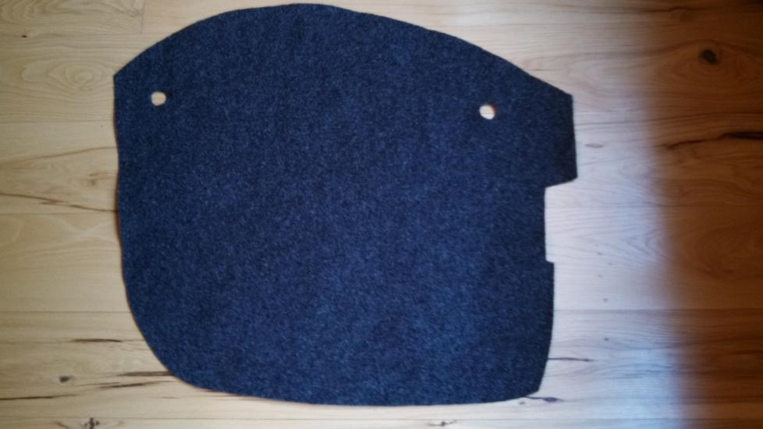

Photo B

You are on the home stretch! Don’t forget you can always clean up any over spray with mineral spirits on a rag.

- We saved the easiest piece in the bag for last. It is the front of the bag. Photo C.
Again, trial fit the piece, spray the liner piece and bag. Start at the top, run along
the sides and stretch if needed to get the seams together. Smooth out with your hands and press firmly. It’s okay if the piece overlaps as long as you have glue on the back it will adhere. Again, clean up if you need to.
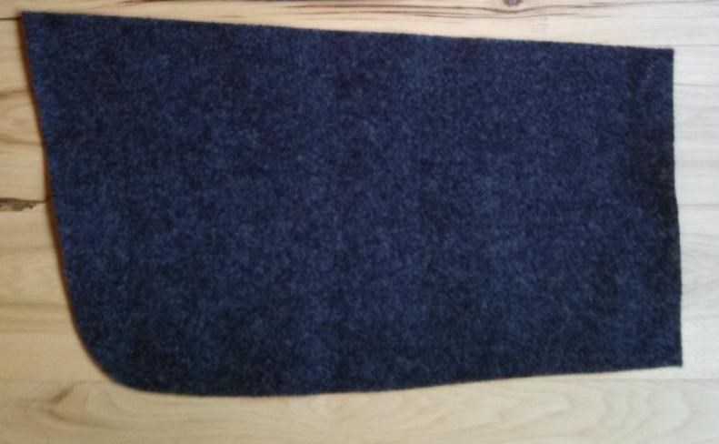

Photo C

LID
Remember we need to tape off the lid first. Trial fit the half-moon piece and this will establish where you need to tape off that edge. Just follow the edge around the rest of the lid coming in approximately ½”. Trial fit the other lid piece making sure the tape off is in the right place. Be sure to tape off the latch completely. Lid pieces are shown in Photo D.
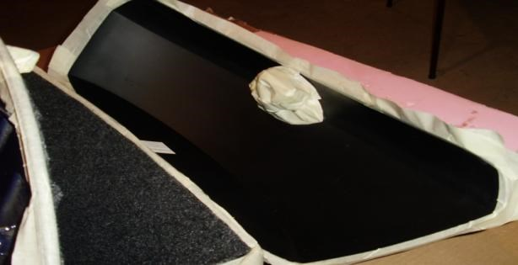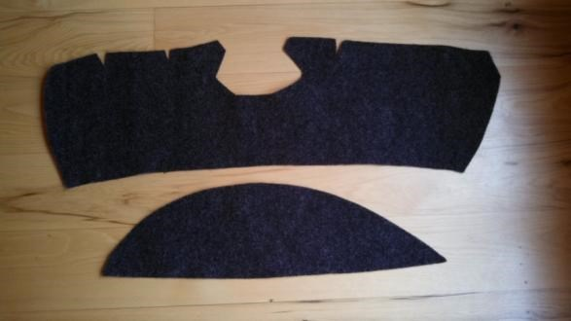

Tape off.

Photo D

- Spray the half-moon liner piece and the lid, put in place and smooth out. Bottom piece shown in Photo D.

- Move to the last piece. Top piece shown in Photo D. While it looks a bit awkward it just requires a bit more smoothing. When you put this piece in you will start by lining it up with the edge of the half-moon piece and working toward the top edge of the lid. The V cuts will close together and are there to allow you to fit around the curve of the lid. Spray piece and lid, put in place and smooth out.

Congratulations you have successfully completed the Left hand side. Wait for touch up until both bags are complete.

Right Side

Now open the bag labeled R and move onto the Right side bag. Again there will be 7 pieces in this bag so begin by repeating instruction numbered 1-3. When you get to 4 there is a slight difference in the piece. There are 3 grommet holes on the Right side piece see photo below. The additional one is for the IPod connection. If you don’t have an IPod hooked up you can just fit the piece as shown in instruction step 4 then complete the remaining steps as outlined.
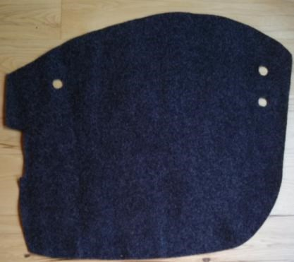
However, if you have a cable with the IPod hookup box coming out of the grommet you will need to take an extra step before putting this piece in. With a sharp scissor; cut in a straight line in between the 2 closest holes (shown on the right of the photo above). It will open this piece up for you to get underneath the IPod hookup. You can easily pull these seams together without looking like it had ever been cut. Proceed putting this piece in as per instructions in number 4; be sure to pull the cut together. Finish out with the remaining steps 5-7.

Touch Up
**Start by cleaning up any areas of glue that you see in the bag. They will appear whiter. Take your rag with mineral spirits on it and rub gently.
**After removing all the taped edges you may expose some areas that need additional glue. Go around all the edges on your bags and check for areas that need touch up. Get some common toothpicks and a scrap of paper. Spray some adhesive from the can on the paper and roll the end of the toothpick in it. Use the glued toothpick to spread the glue on the bag and fabric. Press firmly till it grips
**If you have areas that are not covered by the carpet liner there is an easy fix. Take the scrap piece that was included in your kit with the glue (you should have set this piece aside at the beginning). Cut a piece that is the same size you need to cover the exposed area. Instead of trying to spray glue on a small piece, it is easier to spray the glue on another surface like a piece of cardboard and then wipe the course side of the carpet piece in the glue. Put this piece in place and smooth out. Perfect fit! Repeat in other areas as needed.
Feel free to contact us with any questions at sales@victoryonly.com and we will promptly respond to your questions.
Thank You for Purchasing another Victory Only Custom Accessory
www.victoryonly.com
120 Miller Rd.
Clinton Tn 37716
865-264-4425

