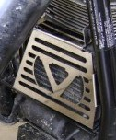 | Warning:  Do not install with the motor warm. This is an install at your own risk. If you are not capable of installing it successfully then we suggest you take this item to a professional shop.
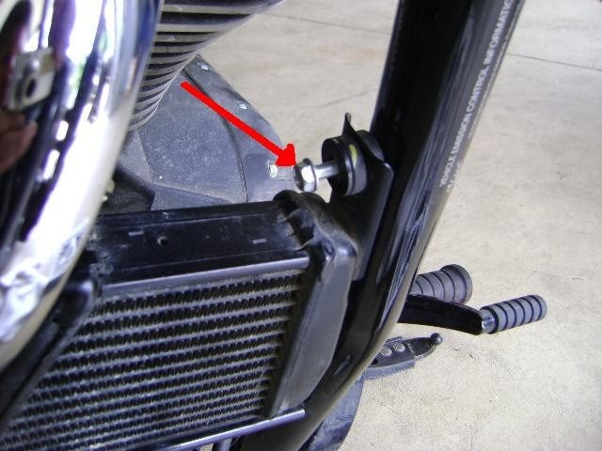 |  | - Remove the protective film on polished stainless oil cooler covers. Use a rag and alcohol or brake cleaner to remove any residue that is left behind.  - Remove the 10mm bolt that secures the oil cooler to the frame.  - Gently lift up on the oil cooler. Make sure the rubber vibration mounts stay in the crossbar. Slide the bottom of the cooler cover between the cooler and rubber mount.  - Slide the top of the cooler in place. Reinstall the 10 mm bolt through the cooler cover and tighten. Check for clearance and fitment on exhaust. After a few miles of riding check for movement and to make sure bolt is tight.
