INSTALLATION INSTRUCTIONS
PART NO. 41-130 FENDER RACKS

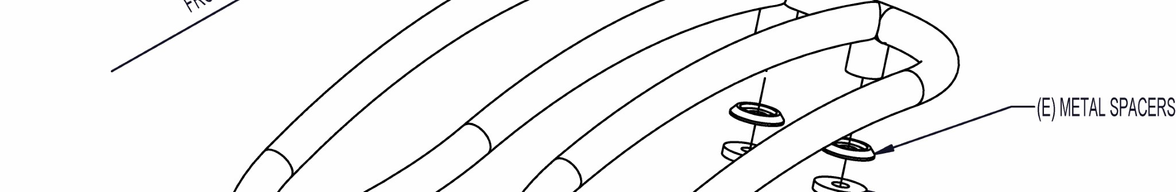
TOOLS NEEDED: DRILL ¼” DRILL BIT MASKING TAPE
4MM ALLEN WRENCH
MARKING PEN

NOTE: WE RECOMMEND USING THREADLOCKER ON ALL HARDWARE INSTALLED.

1
. COVER THE LEGS OF THE RACK (A) WITH MASKING TAPE TO PREVENT SCRATCHING WHEN POSITIONING INTO PLACE.

2
. SET THE RACK (A) ON THE TRIKE FENDER AS THE DIAGRAM SHOWS AND POSITION IT TO YOUR LIKING. MAKE SURE
THAT THE
LEGS OF THE RACK WILL NOT INTERFERE WITH ANYTHING IMPORTANT ON THE INSIDE OF THE FENDER.

3
. LIFT THE RACK (A) SLIGHTLY OFF THE SURFACE OF THE FENDER AND PLACE SHORT STRIPS OF MASKING TAPE UNDER EACH OF
THE FOUR LEGS.

4
. RECHECK THE RACK POSITION AND ADJUST IF NECESSARY. USING THE MARKING PEN, OUTLINE EACH MOUNTING LEG
ONTO THE
MASKING TAPE. REMOVE THE RACK (A) AND MARK THE CENTERS OF EACH CIRCLE WITH THE PEN.

5
. USING THE DRILL WITH THE ¼” DRILL BIT, DRILL THE CENTERS OF EACH OF THE FOUR HOLES MAKING SURE AS T
O NOT DRILL
THROUGH AND HIT THE TIRE. YOU CAN EITHER REMOVE THE WHEEL OR PLACE A BLOCK OF WOOD UNDERNEATH TO PREVE
NT
PUNCTURING THE TIRE.

6
. CAREFULLY REMOVE ALL MASKING TAPE FROM THE FENDER AND THE RACK LEGS. CLEAN IF NECESSARY. ATTACH THE
RACK (A)
TO THE FENDER USING THE M5 BUTTON HEAD SCREWS (B), METAL WASHERS (C), RUBBER WASHERS (D), AND METAL SP
ACERS
(
E) SUPPLIED. THE RUBBER WASHERS (D) ARE PLACED ON EACH SIDE OF THE FENDER.

. REPEAT STEPS 1-6 FOR INSTALLING THE RACK ON THE OPPOSITE SIDE OF THE BIKE.
7

8
. REPLACE THE WHEELS IF THEY WERE REMOVED.

