Installation Instructions- Cross Country Tour Trunk Liner
****Read the entire instructions before you begin****
You’ll thank us later!!

Preparation, Tips and Techniques
Vacuum out and wash interior with a mild detergent like dish soap. Let dry. If you want to take the trunk off the bike it will make it easier to install the liners.
Tape off (using masking tape) the rubber seal around the bottom and lid of the trunk. Tape off any latches etc. Rule of thumb …if you don’t want glue on, tape it off.
The liner has some stretch, pieces are cut to fit. DO NOT STRETCH OR PULL ON THEM PRIOR TO INSTALLATION! Only stretch if needed during installation.
Mineral spirits and a rag will keep your hands clean and help remove any excess glue that over sprays onto the carpet lining. Keep it near as you work the install.
Find a utensil in your kitchen drawer that has a plastic or wooden handle; use this to smooth out the liner in the hard to reach spots.
A scrap piece is included that may come in handy when you have completed the project. It is your FAILSAFE and will allow you to fill any areas that you were unable to pull together. Set aside for now so you don’t mix it up with the liner pieces. We will go over Failsafe methods at the end of the install.
Lastly, you will be able to tell the face of the liner by the softer side. The side you will glue to the bag is coarser. Make sure you identify it in your trial fit…There is only one way for the piece to fit correctly but make sure you put glue on the correct side.

Let’s get started
Open the bag; there are 10 pieces in this bag. We will start with the bottom of the trunk with the pieces in photo below; these are the trunk bottom and the back of the trunk (piece with speaker holes cut out). Be sure that you have done your tape off before you begin.

- We will begin by installing the bottom first. Trial fit the piece by starting at the back bottom fitting around the waves in the back and then laying the piece toward you and fitting the hole in the piece around the lock. Make sure that you line up
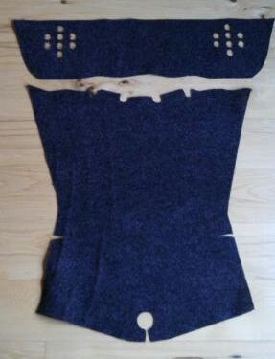
piece with the top edge. When you are comfortable with how it will fit, spray the back of the piece then liberally spray inside the trunk where the piece goes. Immediately put the piece in just like you did with the trial fit. The more glue you spray in the trunk, the easier it will be to slide the piece around. It will take a little longer to set up. Put the piece in place the same as your trial fit, press and work until smooth going around all the indents in the bottom. A household utensil may come in handy as you smooth it out.

- The next piece to install is the back of the trunk, the piece in photo to the left with the 8 holes on each end. Dry fit this piece making sure you are comfortable with how the cut outs fit around the speaker holes in the trunk. You will see that this piece runs across the natural line at the top of the back just
below the plug in for aux power. Before you install this piece you will need to protect the speakers. Our suggestion is to take small pieces of saran wrap and plug each hole.
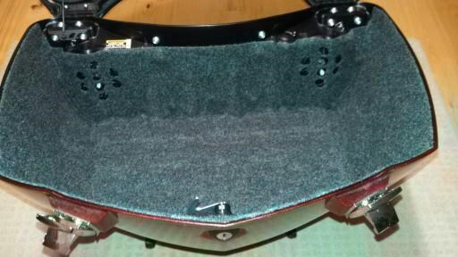
Leave enough stick out so you can pull it out after spraying the trunk. Spray the course side of the liner piece and then liberally spray the back of the trunk, again the more you spray the easier the piece will slide around for fitting. Once sprayed, pull out your saran wrap pieces. Start by lining up
the holes, then line up the top edge and work out to the corners and down toward the bottom of the trunk, stretching as needed. Smooth out.
**As the glue dries, the liner will continue to draw into the crevices of the trunk**
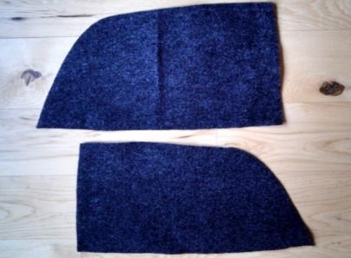
3. The 2 pieces in Photo below are the sides of the trunk bottom. Find the course side that gets glued to trunk to determine the right and left sides. These pieces will slightly over lap the bottom piece that you put in first. (Over lapping pieces is not an issue as long as you secure them with glue). Trial fit the pieces working only one side at a time. Spray glue on the course side of the piece then the trunk area. Put this piece in by starting at the top two corners and lining
up with the top edge. Work down into the trunk and down the sides smoothing out and pressing the overlap areas securely. Repeat on other side.
You have completed the trunk bottom and we will come back for any touch up when you have finished the lid.

The Lid
Be sure that you have taped off any rubber, latches, etc that you don’t want glue on. You may want to disconnect the lid cable as well. The lid is broken down into 6 pieces.
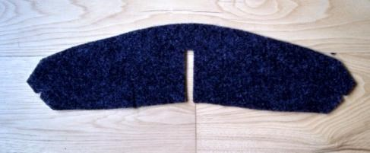
- We will start at the tip of the lid by the latch. The piece you will use is shown to the left. Again, trial fit the piece, making sure you have the course side of the liner against the lid. This piece wraps down and around
the ledge in the tip of the lid. When ready spray the back of the piece with adhesive then the area of the lid where the piece fits. Line up the top edge and work the piece out and down, trying not to stretch unless you need to.

- The next piece we’ll install is the lower part of the lid. See photo below. The location of this piece is shown with the arrows on the picture to the right. There are two filler pieces that will go in after this piece is installed. The arrows on the picture on the left show where those filler pieces will go. So let’s get this piece installed. Trial fit first; the slit in the piece will fit in the center at the bottom of the long rubber protector, the piece will wrap around and down the ledge and fit across the very bottom of the lid, with the wings on each side of the piece sitting on the upper ledge. Take your time on the dry fit to make sure you know how this piece fits. Spray the course side of the piece and then the area of the lid. We recommend you begin the install of the piece along the bottom edge first and get it lined up at the outside corners (shown below Right with the lower arrows) and work the piece up and around. Stretch the piece only if needed. Smooth out.
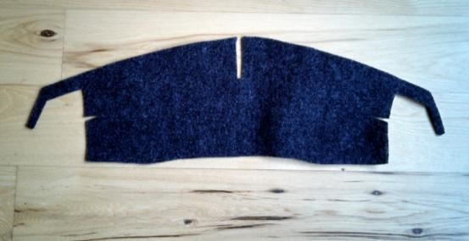
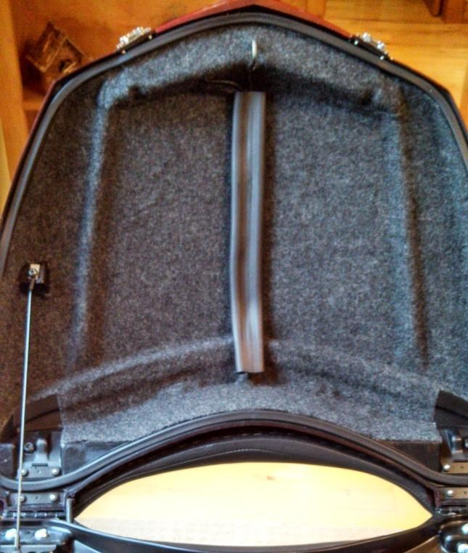
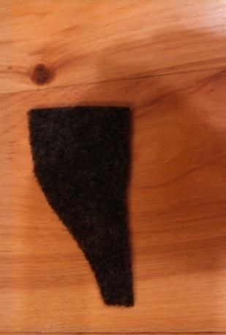
exactly where these pieces go. The circles on the picture to the right show where they go. Below is the piece, which you will have a left and a right piece. Do a quick trial fit, be sure you have the correct sides identified. Work one piece at a time and spray the course side then spray adhesive on the area in the lid. Put in place, press and smooth. Repeat with the other piece.

6.

The next two pieces are the fillers
. With
the previous piece in the lid you will see

7. There are two remaining pieces on the lid and your project is nearly complete. Be sure you have taped off the
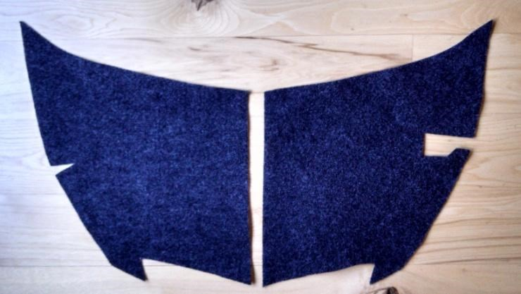
protective rubber. The pieces in the photo will fit into the center of your lid on the right and left as they are shown. You can start with either side. Pull the rubber and hidden wiring out of the way to the opposite side that you are working on. Trial fit the side you have chosen to work first. When ready, spray the course side of the
liner and then spray the lid area. On the install, start at the outside edge of the lid and work toward the center. Press in place and smooth out. Repeat for the other side.
Congratulations!!! You have just completed the trunk liner.

Touch Up
**Start by cleaning up any areas of glue that you see. They will appear whiter. Take your rag dampened with mineral spirits and rub gently until the glue is removed,
**After removing all the taped edges you may expose some edge areas that need additional glue. Go around all the edges on your trunk and check for spots that need touch up. Get some common toothpicks or a small paint brush and a scrap of paper. Spray some adhesive on to the paper and roll the end of the toothpick in it or dip your brush in it. Spread the glue on the bag and fabric. Press firmly till it grips
**If you have areas that are not covered by the carpet liner there is an easy fix. Take the scrap piece that was included in your kit (you should have set this piece aside at the beginning). Cut a piece that is the same size you need to cover the exposed area. Instead of trying to spray glue on a small piece, it is easier to spray the glue on another surface like a piece of cardboard and then wipe the course side of the carpet piece in the glue. Put this piece in place and smooth out. Perfect fit! Repeat in other areas as needed.

Thank You
Victory Only
www.victoryonly.com
120 Miller Rd
Clinton Tn 37716
865-264-4425

